React Recap Questions

1. What is react
2. What is the use of index.js
3. What is the use public folder
4. Use of Src Folder?
5. React Is basixcally ___________ Based application
6. Different Types of Component in React
7. Give an Example functional Component
8. Give an Example for class Component
9. What is Props Why do need
10. Can we change the props value in the component
11. Can we change the state value in the component
12. What is state
13. Use of setState() and give an example
14. Is Functional components supports for state by default ?
15. If yes Given an Example .If no write a reason and how to maintain the state in Functional Component
16. Can we set the default value for props or not
17. Can we pass Multiple values to the props? And an Example
18. Example to set the default value to the prop
19. How to apply the style for and Element. give an example
20. Use of App.Js
21. Can we run react app without app.Js? if yes how to do so?
22. In index.js file you the below code

const root = ReactDOM.createRoot(document.getElementById('root'));

where that root is present?

1. Create a component with the name of ExpenseItem and display the below output from it

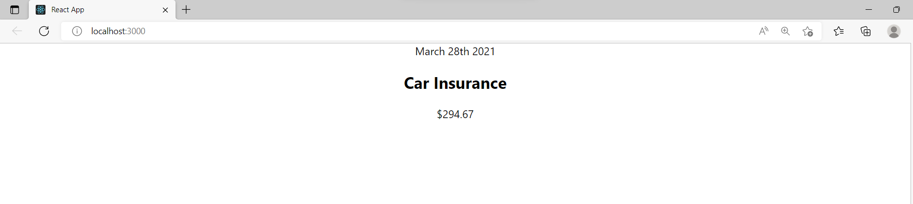

1. **Create one File With the name of ExpenseItem.css**

**.expense-item {**

**display: flex;**

**justify-content: space-between;**

**align-items: center;**

**box-shadow: 0 2px 8px rgba(0, 0, 0, 0.25);**

**padding: 0.5rem;**

**margin: 1rem 0;**

**border-radius: 12px;**

**background-color: #4b4b4b;**

**}**

**.expense-item__description {**

**display: flex;**

**flex-direction: column;**

**gap: 1rem;**

**align-items: flex-end;**

**flex-flow: column-reverse;**

**justify-content: flex-start;**

**flex: 1;**

**}**

**.expense-item h2 {**

**color: #3a3a3a;**

**font-size: 1rem;**

**flex: 1;**

**margin: 0 1rem;**

**color: white;**

**}**

**.expense-item__price {**

**font-size: 1rem;**

**font-weight: bold;**

**color: white;**

**background-color: #40005d;**

**border: 1px solid white;**

**padding: 0.5rem;**

**border-radius: 12px;**

**}**

**@media (min-width: 580px) {**

**.expense-item__description {**

**flex-direction: row;**

**align-items: center;**

**justify-content: flex-start;**

**flex: 1;**

**}**

**.expense-item__description h2 {**

**font-size: 1.25rem;**

**}**

**.expense-item__price {**

**font-size: 1.25rem;**

**padding: 0.5rem 1.5rem;**

**}**

**}**

**Apply the above css class to your ExpenseItem elements. How To apply?**

<div>

        <div>March 28th 2021</div>

        <div>

          <h2>Car Insurance</h2>

          <div>$294.67</div>

        </div>

      </div>